Stock Data and Portfolio Analysis through Data Visualization
Thus, today’s dynamic financial markets require valuable and concise methods to analyze stock performance and portfolio statistics. In the current project, using content analysis, the past stock prices and portfolio performance indicators are studied and trend patterns derived from these studies are used in evaluating future investments. Interactive visualizations help users analyze stock trends, evaluate a portfolio’s condition, and make changes that generate higher returns with lower risk in this manner.
This work aims at creating data representations of stock market data and of individual and/or company portfolios in order to address issues regarding risk and return of particular stocks.
Problem Statement
The primary objective of this project is to analyze stock performance trends and portfolio metrics to understand market behavior and the profitability of specific investments. By visualizing daily price changes and portfolio holdings, this analysis aims to provide insights into stock volatility, performance over time, and investment growth.
Data
Historical Stock Data
The stock data provides a time-series record of daily closing prices and percentage changes for various stocks. This dataset includes:
- Stock Ticker: The unique identifier for each stock, allowing for tracking of specific stocks overtime
- “GOOGLEFINANCE” function: This function in Google Sheets allows to pull real-time or historical market data directly into the spreadsheet.

Basic syntax
=GOOGLEFINANCE("ticker", "attribute", [start_date], [end_date|num_days], [interval])

Modified syntax
=GOOGLEFINANCE(A2, "price", EDATE(TODAY(), -12), TODAY())

A2 refers to the cell where the stock ticker symbol (AAPL for Apple) is stored, “price” the attribute specifying to retrieve that historical daily price of the stock, EDATE(TODAY(), -12)
Calculates the start date from the data range, which is exactly 12 months before today, TODAY() sets the end date for the data range as today’s date.

- Daily Percentage Change: The day-to-day percentage change in stock price, a critical metric for assessing volatility and trends.

Stock Portfolio Data
The portfolio data details the investment positions held within a hypothetical or actual portfolio. This dataset includes:
- Stock Name: Ticker symbols corresponding to the stock in the portfolio, allowing for alignment with historical stock data.
- Units Bought: The number of shares purchased for each stock, crucial for the calculation of the total value and changes into portfolio worth.
- Price When Purchased: The acquisition cost of a share forms the standard in valuing the rises or declines.
- Purchase Cost: The total cost of each investment position, calculated as units bought multiplied by the purchase price, providing a basis for analyzing the return on investment.

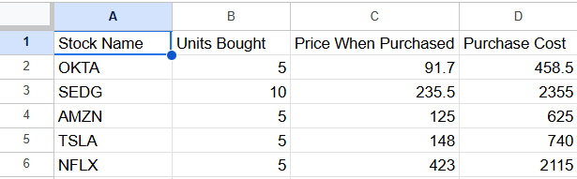Both datasets are created and compiled for analysis and visualization in Tableau.

Project Scope
This project focuses on analyzing stock performance and portfolio metrics through data visualization to support strategic investment decisions.
- Stock Performance Analysis: Visualizing historical price trends and daily percentage changes to identify patterns, growth potential, and volatility for individual stocks.
- Portfolio Evaluation: Portfolio holdings can be appraised based on parameters such as total cost, mean cost and general return. This enables shareholders to differentiate from one stock to the other the performance they had on the portfolio.
- Risk and Return Insights: Effective visualization of the portfolio risk-return characteristics allows the investor to assess the risk level of portfolio stocks and expected returns. This insight is helpful in making wiser decisions concerning portfolio adjustments to make.
- Interactive Dashboard Creation: By developing an informing Tableau dashboard Including the stock Level as well as other Portrait Information, the users are able to filter informaiton easily they need. It is useful for gaining a quick snapshot and it and is used for portfolio strategy adaptation.

Literature Review
Business intelligence is now Central to financial analysis particularly when analyzing trends in the stock market and performance of a portfolio. Complex data can be processed into more easy to understand visual displays and analysts as well as investors will be in a position to note certain issues that may not be evidently clear from the figures.
Impact of Data Visualization on Stock Market Analysis
Studies demonstrate that data visualization enhances the ability to understand stock price trends, volatility, and market movements, especially for retail investors who may lack advanced statistical skills. According to research by Chourmouziadis and Chatzoglou (2016), visualizations like candlestick charts, moving averages, and price-volume trends are highly effective for detecting anomalies and forecasting short-term trends in stock prices. Visualizations also facilitate comparative analysis across different securities, allowing investors to benchmark performance and volatility, as seen in Chen et al. (2020).

- Portfolio Analysis through Visual Tools
Portfolio visualization helps investors monitor portfolio diversification, asset allocation, and individual stock performance relative to portfolio objectives. For example, Lee and Lee (2017) argue that portfolio visualizations, such as risk-return plots and sector heat maps, provide investors with a clear view of their holdings' risk profile, supporting more informed rebalancing decisions. Effective portfolio visualization tools are particularly valuable in volatile markets, where quick adjustments may be necessary to minimize losses or capture gains.

- The Role of Visualization in Managing Investment Risk
Investment risk management is another area significantly improved by data visualization. Studies show that visualizations like value-at-risk charts, Sharpe ratio histograms, and drawdown curves help investors understand the historical risk profile of individual stocks and portfolios. Research by Huang and Litzenberger (2018) highlights that such visual aids are essential for interpreting risk metrics and assessing the alignment of portfolios with individual risk tolerance levels.

- Visualization Techniques for Investor Decision-Making
Modern visualization techniques, including interactive dashboards and real-time visual updates, enable investors to track stock and portfolio performance dynamically. According to Petrini and Pozzoli (2019), interactive visualizations in platforms like Tableau or Power BI allow users to filter and adjust parameters, thus creating personalized insights. Such tools are critical for enhancing investor confidence and decision-making accuracy, particularly as they bridge the gap between complex analytics and actionable insights.

- Comparative Performance and Sector Analysis
Sector-based comparative analysis through visualizations allows investors to understand the performance of specific industries or stock categories. This is particularly useful in diversified portfolios, where sectoral performance can vary widely. Studies by Kim et al. (2021) reveal that visualizations showing sector breakdowns and trends aid in identifying outperforming or underperforming segments, helping investors to decide on allocation shifts that align with market cycles.

Research Questions
- What are the trends in closing prices and daily percentage changes for each stock?
- How does portfolio performance align with individual stock performance?
- What are the comparative risks and returns associated with each stock in the portfolio?

Significance of the Study
This analysis provides investors and financial analysts with actionable insights into stock market behavior, enabling them to evaluate investment performance and make informed portfolio adjustments.

Descriptive Statistics
- Stock Price Trends: Average, maximum, and minimum closing prices for each stock.
- Portfolio Summary: Total investment cost, average purchase price, and potential returns based on recent prices.

Stock Performance Dashboard
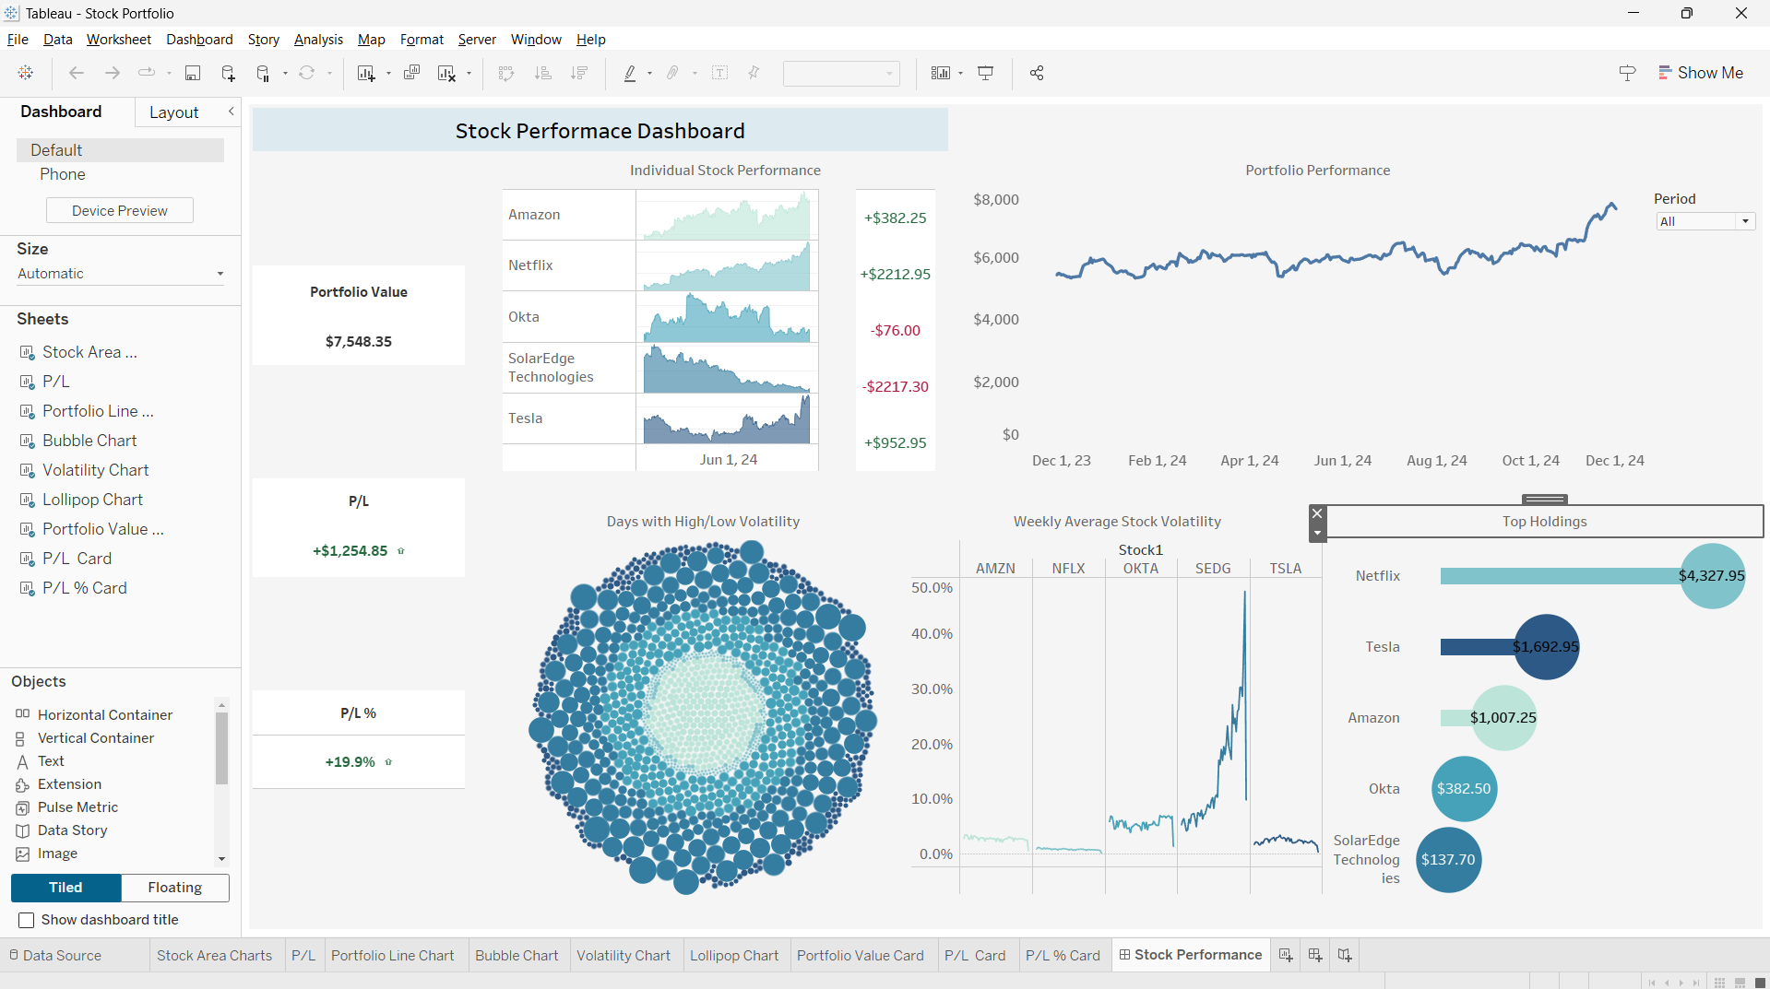

Key Insights
- Portfolio Value

The total value of the portfolio is displayed as $7,548.35.
This is a snapshot of the portfolio's current standing. It indicates the combined value of all stocks held, providing a quick view of the portfolio's overall health.

- P/L (Profit/Loss)

Absolute P/L: +$1,254.85 shows the net profit made from the portfolio.
Percentage P/L: +19.9% reflects the portfolio's profitability relative to its initial value.

The portfolio is profitable overall, with a healthy return of nearly 20%, which is a positive indicator of performance.

- Individual Stock Performance

Each stock has its own sparkline showing performance over time and a corresponding P/L value:

Amazon:
P/L: +$382.25
Insight: Modest but steady growth.

Netflix:
P/L: +$2,212.95
Insight: Top performer with significant gains, likely driving the portfolio’s profitability.

Okta:
P/L: -$76.00
Insight: Slight loss, indicating underperformance compared to others.

SolarEdge Technologies:
P/L: -$2,217.30
Insight: Major underperformance, dragging down the portfolio due to volatility or negative market trends.

Tesla:
P/L: +$952.95
Insight: A strong contributor to gains, with positive momentum visible in the sparkline.

- Portfolio Performance Over Time

The chart shows fluctuations in the portfolio’s total value. Despite minor dips, the overall trend is upward, ending in a sharp rise.

Indicates consistent improvement and suggests recent gains that contributed to the current portfolio value.

- Days with High/Low Volatility

Larger circles represent days with higher volatility. The distribution of circle sizes provides a quick glance at the frequency of high or low volatility days.

High-volatility days might correspond to significant movements in specific stocks, such as SolarEdge Technologies, which could help inform risk management strategies.

- Weekly Average Stock Volatility (Bar and Line Graph)

Insights by Stock:

SEDG (SolarEdge Technologies): Extremely high volatility, likely correlating with its poor performance.

AMZN (Amazon): Relatively stable with low volatility, matching its steady growth.
NFLX (Netflix): Moderate volatility but still highly profitable.
TSLA (Tesla): Occasional spikes in volatility but profitable.
OKTA (Okta): Low-to-moderate volatility but showing slight losses.
Relevance: Helps identify the risk associated with each stock and allows comparison between performance and volatility.

- Top Holdings

Netflix: Dominates with $4,327.95, contributing over half the portfolio’s value.
Tesla: Second largest holding at $1,692.95.
Amazon: Significant contributor at $1,007.25.
Okta: Relatively minor holding at $382.50.
SolarEdge Technologies: Lowest holding at $137.70, reflecting poor performance.

Insight: Highlights which stocks contribute most to the portfolio value, offering a clear view of concentration and diversification.

Stock Portfolio Performance using KNIME
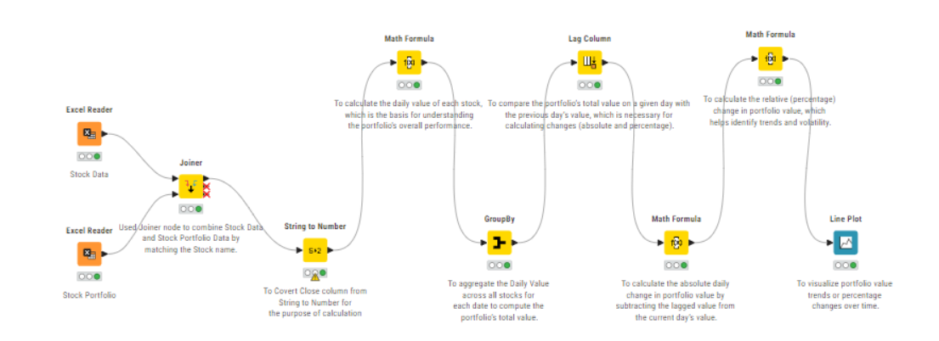
- Excel Reader
The purpose of using these nodes was to read the Excel files that contain Stock data and portfolio data.

- Joiner
Combines the stock data and stock portfolio data based on matching stock names.

- String to Number
Converts the "Close" column from a string to a numeric format for calculations.

- Math Formula
Calculates the daily value of each stock, serving as the basis for understanding the portfolio's performance.

- GroupBy
Aggregates daily values across all stocks for each date to compute the total portfolio value.

- Lag Column
Compares the portfolio's total value on a given day with the previous day's value.

- Math Formula (Absolute Change)
Computes the absolute daily change in portfolio value by subtracting the lagged value from the current day's value.

- Math Formula (Percentage Change)
Calculates the relative (percentage) change in portfolio value to help identify trends and volatility.

- Line Plot
Visualizes portfolio value trends or percentage changes over time.

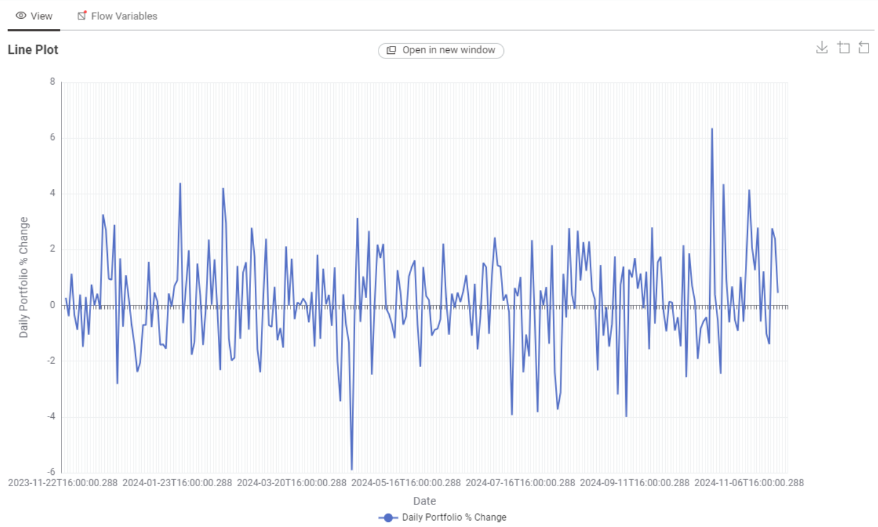

References
- View article. (n.d.). Google.Com. Retrieved November 27, 2024, from https://scholar.google.com/citations?view_op=view_citation&hl=en&user=Jdscc9wAAAAJ&citation_for_view=Jdscc9wAAAAJ%3A0EnyYjriUFMC&inst=11260932423437556621
- Chen, Chiang, & Storey. (2012). Business intelligence and analytics: From big data to big impact. MIS Quarterly: Management Information Systems, 36(4), 1165. https://doi.org/10.2307/41703503
- Foundations for Financial Economics. (n.d.). Google Books. Retrieved November 27, 2024, from https://books.google.com/books/about/Foundations_for_Financial_Economics.html?id=KIOxAAAAIAAJ
- VectorVest. (2024, August 22). Creating a Diversified Portfolio Using Sector Analysis. VectorVest. https://www.vectorvest.com/blog/stockmarket/creating-a-diversified-portfolio-using-sector-analysis-a-guide-for-retail-investors/
- AMZN Stock Price. (n.d.). MarketWatch. Retrieved November 27, 2024, from https://www.marketwatch.com/investing/stock/amzn
- OKTA Stock Price. (n.d.). MarketWatch. Retrieved November 27, 2024, from https://www.marketwatch.com/investing/stock/okta
- SEDG Stock Price. (n.d.). MarketWatch. Retrieved November 27, 2024, from https://www.marketwatch.com/investing/stock/sedg
- TSLA Stock Price. (n.d.). MarketWatch. Retrieved November 27, 2024, from https://www.marketwatch.com/investing/stock/tsla
- NFLX Stock Price. (n.d.). MarketWatch. Retrieved November 27, 2024, from https://www.marketwatch.com/investing/stock/nflx
- Google Sheets training and help. (n.d.). Google.com. Retrieved November 27, 2024, from https://support.google.com/a/users/answer/9282959?hl=en&sjid=1066214067796017946-NA

